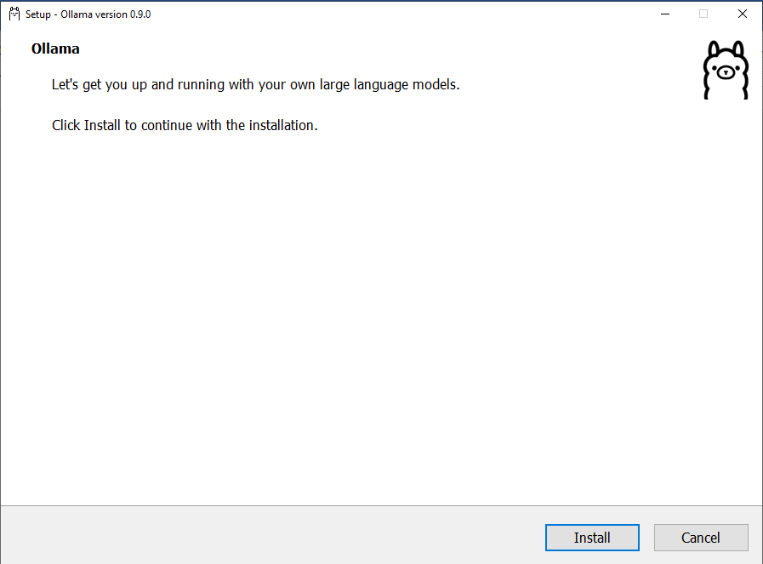

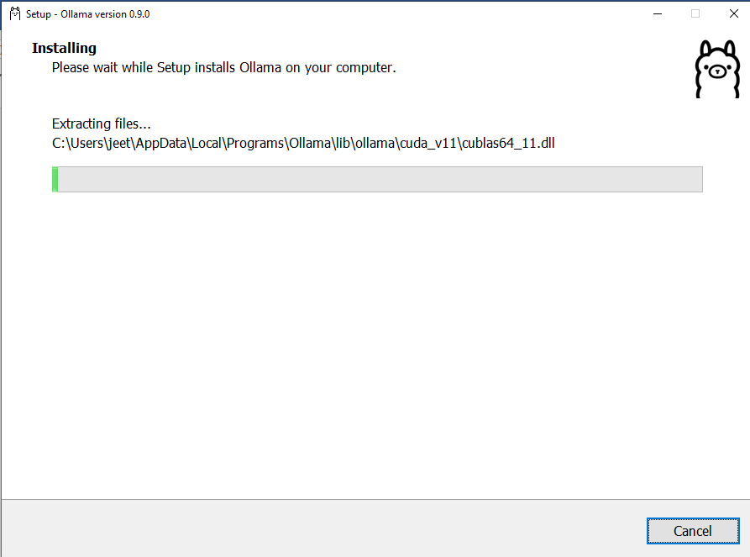

It will finish automatically and start running, you will the running status of OLLAMA at the bottom right side

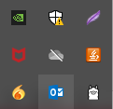

Steps to run the project:
- Create a virtual env
- Go to the folder and install requirements using “pip install -r requirements.txt”
- ollama pull mistral
- python manage.py migrate --database=logs
- Migrate the db using “python manage.py makemigrations”, “python manage.py migrate ”, “python manage.py createsuperuser”
- Run the program using “python manage.py runserver”

